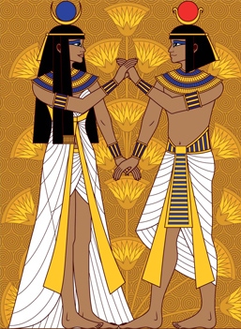
Lesson 4
The Ancient Egyptians.
This week we are continuing to read the book ‘The Ancient Egyptians’.
Open the book that has been attached. It is a PDF file.

Read the sections called ‘Daily Life, Keeping Clean, Clothing and Finishing Touches’.

Task
- Using the book to help you, draw a picture of an Egyptian man and an Egyptian woman wearing the clothes that you have read about from the book.
- Underneath the drawings, write a paragraph writing all about the clothes and jewellery that the Egyptians wore.
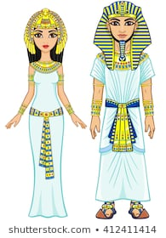

Lesson 5
The Ancient Egyptians.

Open the book that has been attached. It is a PDF file.

Read the sections called ‘Daily Life, Keeping Clean, Clothing, Finishing Touches, Home Sweet Home and Dinner Time’.
Task
Answer the questions carefully and make sure your handwriting is beautiful.

Where did the Egyptians bathe? What did they use to keep themselves clean? (2b)

Why did the Egyptians carry an amulet? (2b)

Why do you think that it was important to the Egyptians to look nice? (2d)

Why do you think trees were rare? (2d)

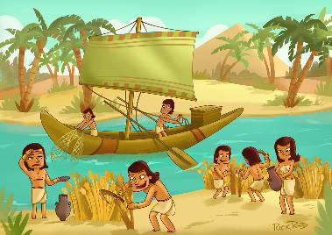
Lesson 6
The Ancient Egyptians.

Open the book that has been attached. It is a PDF file.

Read the section called ‘The Nile’, please read both pages.

Task
Using all the information about the River Nile from the book, create your own fact file about one of the most famous rivers in the world, the River Nile.
To make your fact file stand out to the reader, you could use:
- Different styles of writing, such as bubble writing or block writing.
- Use boxes with writing inside.
- Different colours and pictures.
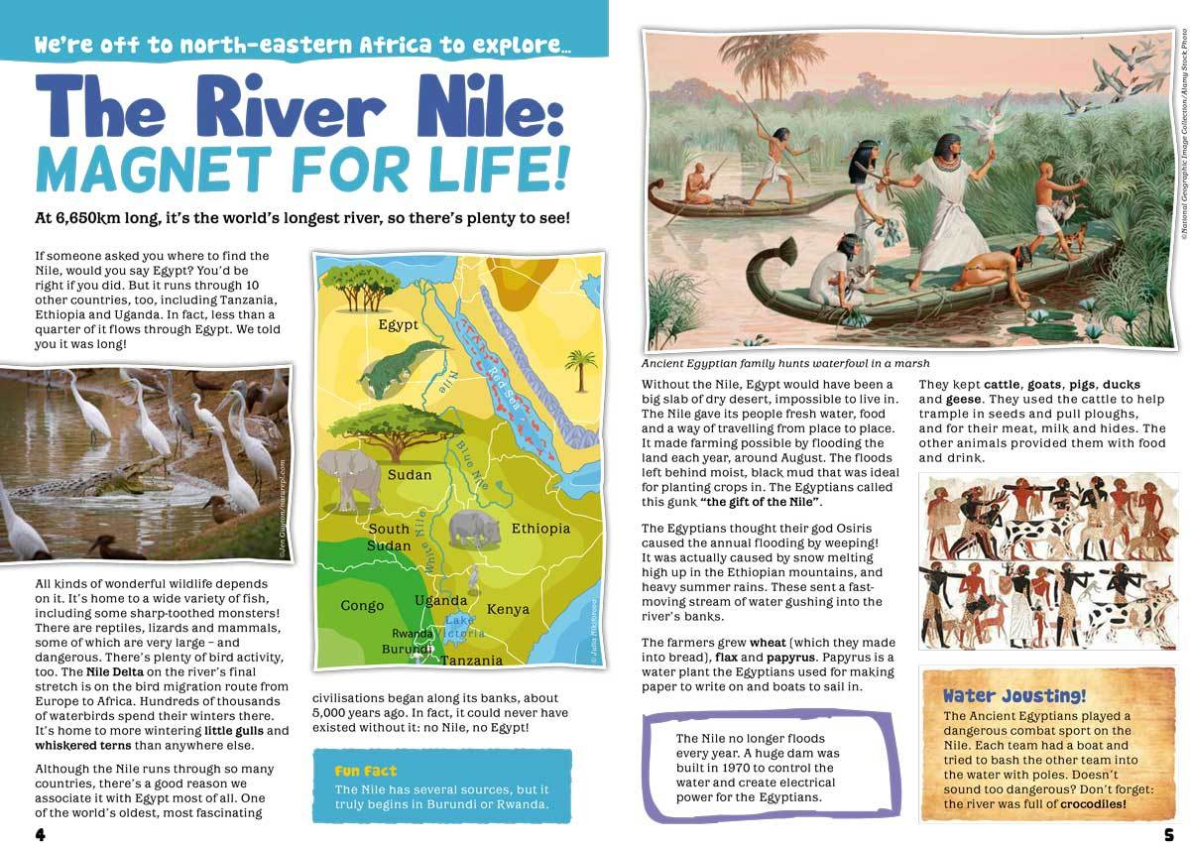
- Title and sub headings.

