Science – lesson 6
Identify the different teeth that humans have
What do you remember about your digestive system? Write here: It is not just about poo!

Watch this power point to start with.
Teeth Exploration
You will need:
• A partner
• A mirror
Look at your partner’s teeth. Use the diagram below to show what teeth they have. Cross out any missing teeth. If you recognise any milk (baby) teeth, write ‘M’ on them. If you recognise any adult teeth, write ‘A’ on them. Then, if you can, label incisors, canines, premolars and molars.
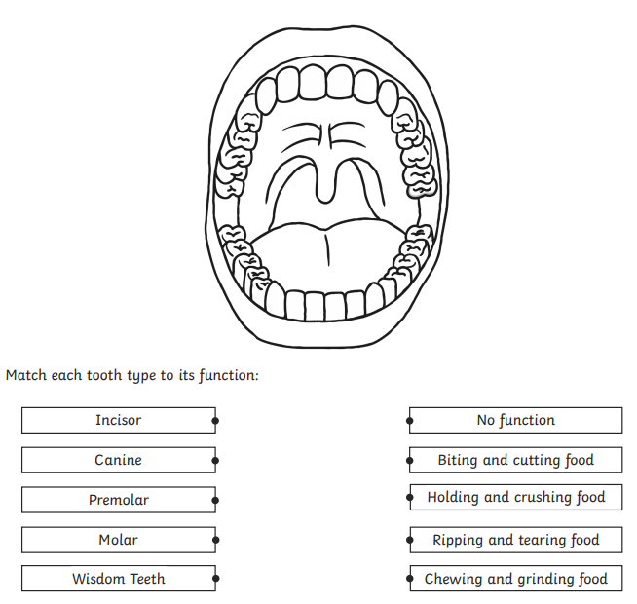
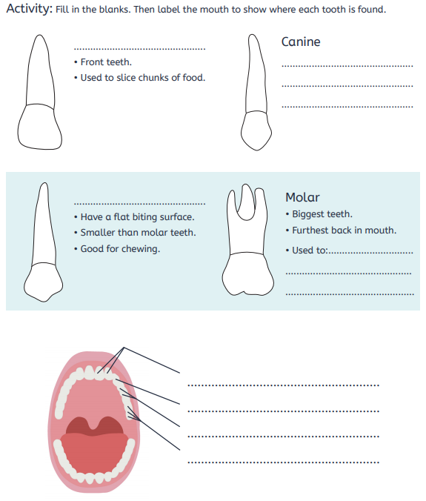

If you are unsure – watch this information video and then come back to the work

https://www.youtube.com/watch?v=ZE-TtFhZlDw

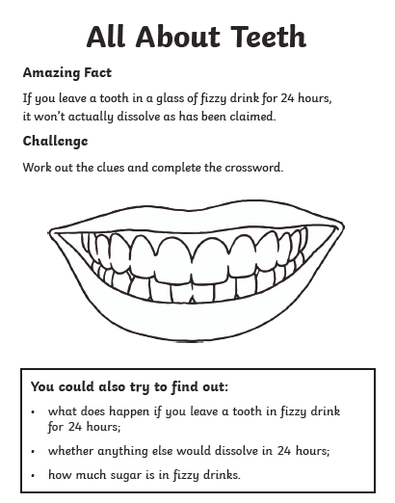
Experiment: Tell me what you found out (If you do not have a tooth, use egg shell)

