Lesson 1
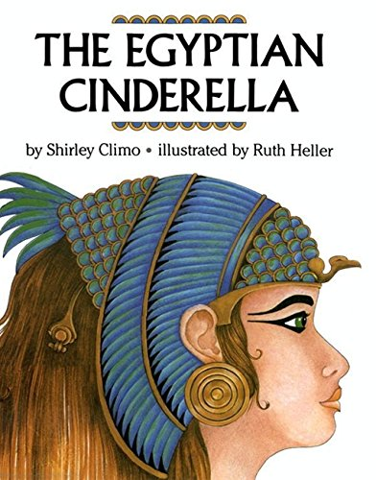
Literacy
This term, we are learning all about the Ancient Egyptians, for the next couple of weeks, our literacy is linked to this theme.
The fiction book ‘The Egyptian Cinderella’ is the story we are going to be looking at and all our work is going to be based on the book.
Task 1
Before you read the book, write a short prediction about what you think the book will be about.
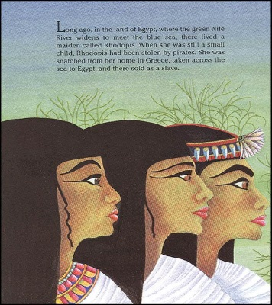
Now, read the story ‘The Egyptian Cinderella’, click on the link below and follow the story as you listen to the book being read to you.

https://www.youtube.com/watch?v=dSVfIc4l8Lk

Task 2
Was your prediction correct?
Write in a few sentences, which parts of the story did you predict were correct and which parts were not correct.
(Remember to upload a picture of your work onto Class Dojo.)
Lesson 2
Give your family a summary of the story ‘The Egyptian Cinderella’.

Read the story, click on the link below and follow the story as you listen to the book being read to you.
https://www.youtube.com/watch?v=dSVfIc4l8Lk
The book reminds us of a story we all know called Cinderella.
Think about both stories, what do you think is the same about both stories? What do you think is different about the stories?
Task.
Write about the similarities (what is the same) and differences (what is different) about both stories, ‘The Egyptian Cinderella’ and ‘Cinderella’.
Set your work out using the subheadings, similarities and differences and write as many as you can.

Similarities

Differences

(Remember to upload a picture of your work onto Class Dojo.)
Lesson 3
Read the story, click on the link below and follow the story as you listen to the book being read to you.
https://www.youtube.com/watch?v=dSVfIc4l8Lk

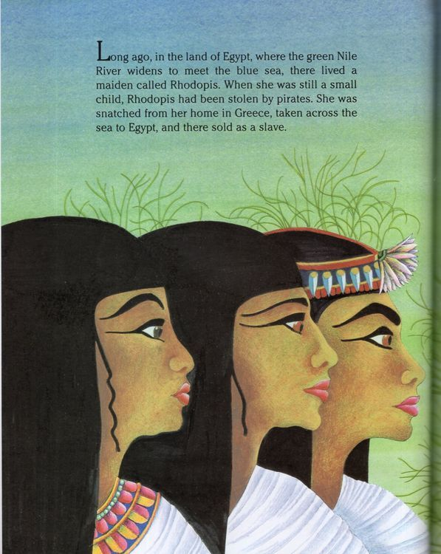
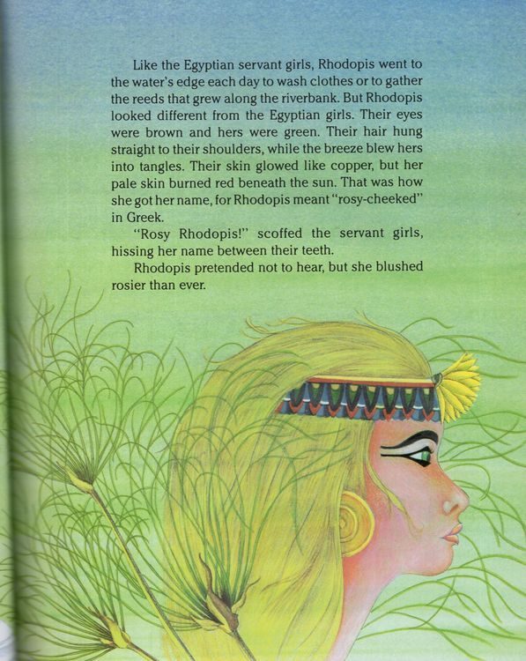
Today, we are going to focus on the first two pages of the story.
You can if you want to, pause the story at the first two pages so you can keep referring back to it.
Task
Copy the paragraph below and highlight all the adjectives. One has been done for you.
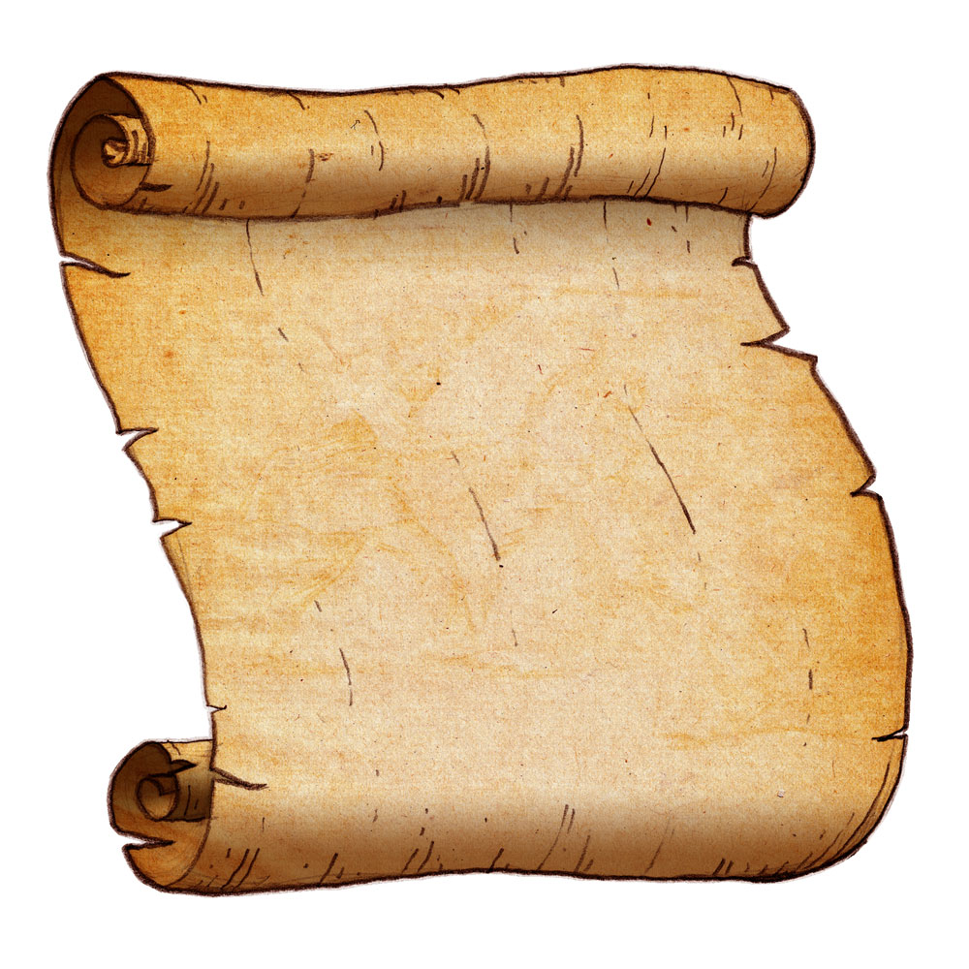
Challenge
Long ago, in the land of Egypt, where the green Nile River widens to meet the blue sea, there lived a lovely maiden called Rhodopis. When she was still a small child, Rhodopis had been stolen by awful pirates. She was snatched from her wonderful home in Greece, taken across the sea to Egypt and there sold as a slave.

If you would like to challenge yourself…
Write the paragraph again and add more adjectives to create expanded noun phrases.
For example; Long ago, in the land of Egypt, where the mysterious, green Nile River…
(Remember to upload a picture of your work onto Class Dojo.)
Lesson 4
You do not have to read the story today, but if you wanted to, click on the link below and follow the story as you listen to the book being read to you.
https://www.youtube.com/watch?v=dSVfIc4l8Lk

Today we are going to be thinking about a characters feelings at different points of the story. Look at the picture below and think about how Rhodopis is feeling at that part of the story.
Task
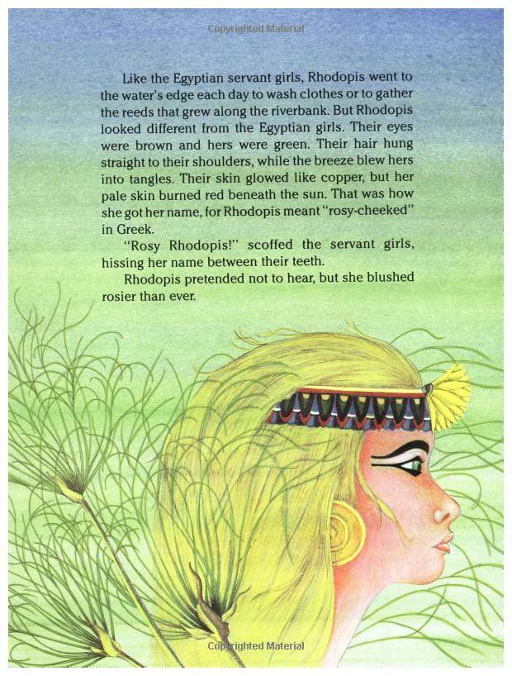
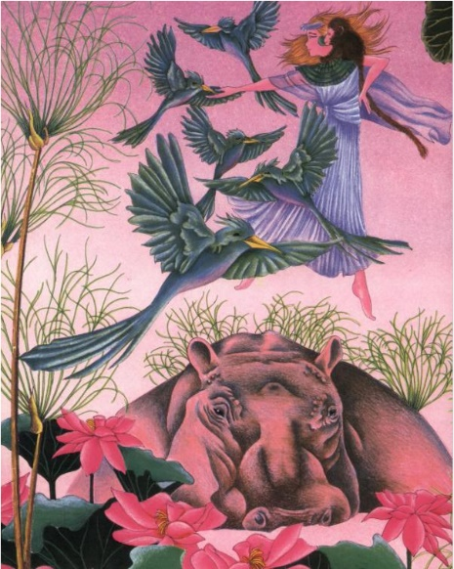
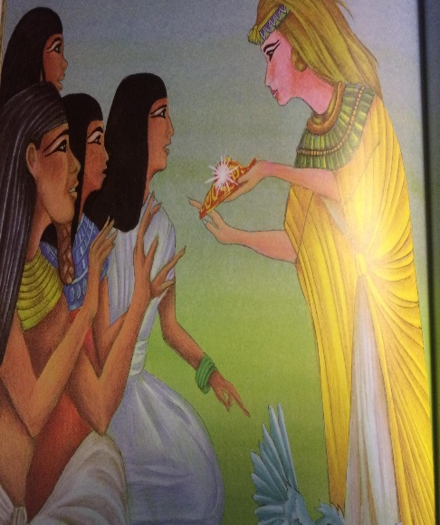
Look at the pictures from the story, write how you think the character is feeling at that point in the story and why you think that. You can use the story to help you, pause it at the picture.

(Remember to upload a picture of your work onto Class Dojo.)
Lesson 5
You do not have to read the story today, but if you wanted to, click on the link below and follow the story as you listen to the book being read to you.
https://www.youtube.com/watch?v=dSVfIc4l8Lk

Today we are going to focus on Rhodopis dancing in the garden surrounded by all of her animal friends.
What do you think Rhodopis is thinking while she is dancing? What could she be saying whilst she is dancing?
Task
Write in speech bubbles, what could Rhodopis be saying while she is dancing. Write in thought bubbles what is Rhodopis thinking while she is dancing.
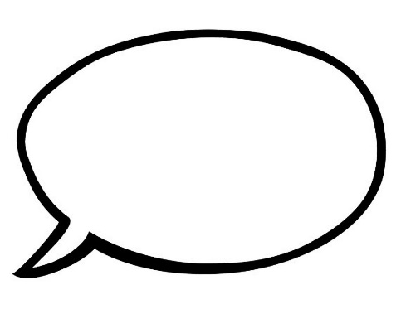
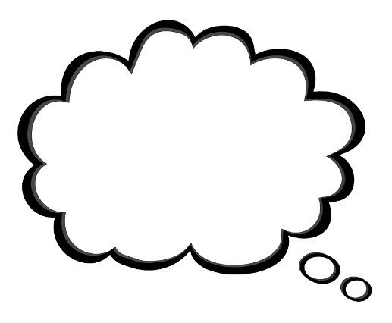
Rhodopis is saying…
Rhodopis is thinking…

(Remember to upload a picture of your work onto Class Dojo.)

