**Science – lesson 4**

**Identify different muscles in our body and what they do**

|  |
| --- |
| ***What do you know about Skeletons?*** *Write here:* |

First, we are going to look at the muscles power point. Open up the power point [here](file:///C:\Users\pfarman\Desktop\Animal%20Skeletons%20-%20powerpoint.mp4)

|  |
| --- |
| **Task 1** – Label the main bones of the body. If you want to impress me, write down the scientific names e.g. back bone 🡪 spine (vertebrates) |

The Human Skeleton

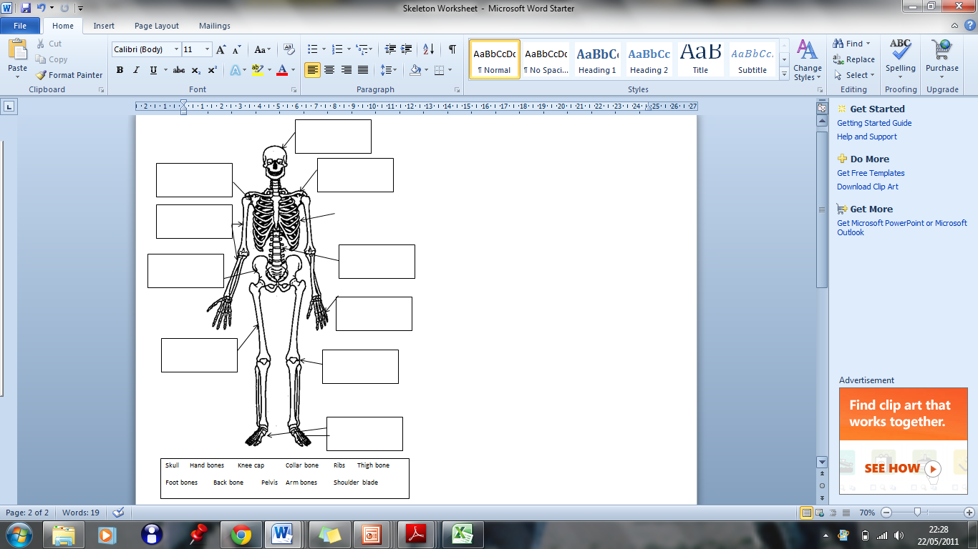

|  |
| --- |
| ***Task 2 - fill in the missing blanks using these words***  650 relaxing fatter longer relax  Bones contract thinner relax |

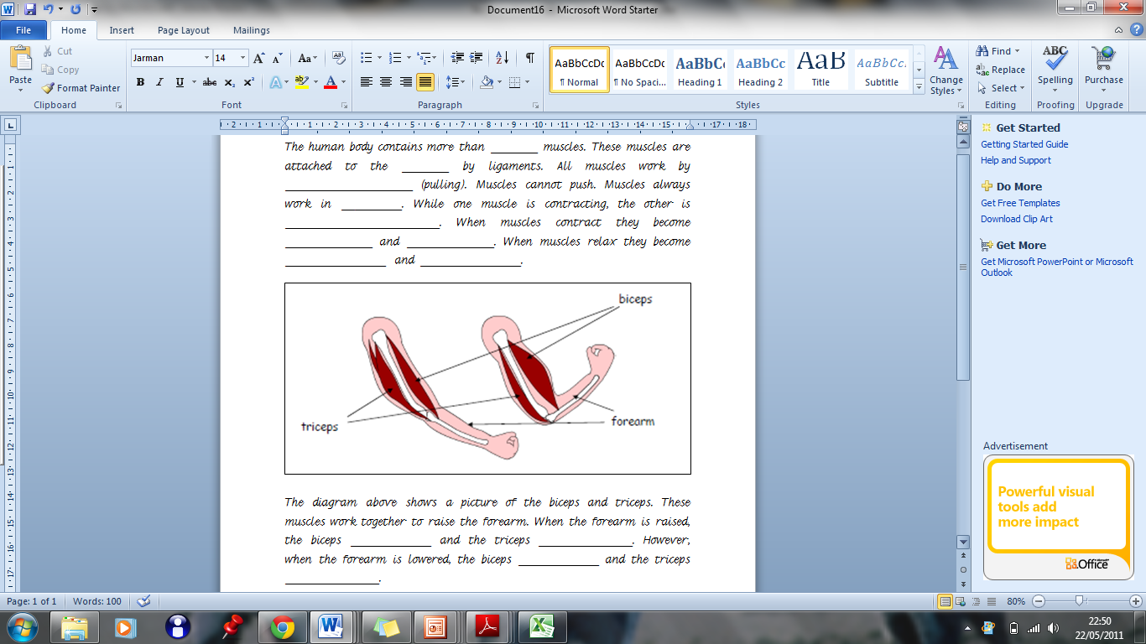

**Task 3**

**Identifying and using muscles**

**Some of the body’s main muscles**

MCHM00247_0000[1]

Jaw muscle

Shoulder muscles

Pectoral (chest muscles)

Abdominal (stomach muscles)

Triceps

Biceps

Thigh muscles

Forearm muscles

Calf muscles

Complete the table by identifying the **main** muscles used when carrying out the following everyday household activities and jobs:

|  |  |
| --- | --- |
| EXERCISE/ACTIVITY | MUSCLES USED |
| walking up stairs | \* |
| drinking | \* |
| washing the dishes | \* |
| vacuum cleaning | \* |
| brushing your teeth | \* |
| flushing the toilet | \* |
| getting out of bed | \* |
| opening a door | \* |

Answer the following questions by typing each answer in the text box.

1) What happens to a muscle when it contracts?

\*

2) What are all of our muscles attached to?

\*

3) Explain two ways by which we can keep our muscles strong and healthy.

\*