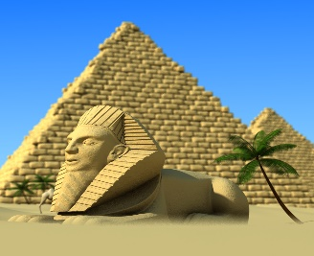
Lesson 7
The Ancient Egyptians.
This week we are continuing to read the book ‘The Ancient Egyptians’.
Open the book that has been attached. It is a PDF file.
Read the sections called ‘Pyramids, Afterlife, The Tomb and The Sphinx’.

Task
Answer the questions carefully and make sure your handwriting is beautiful.
Why were the Pyramids built? (2b)

Why were the Pyramids different sizes? (2b)

Why do you think it was important to write about the Pharaohs achievements? (2d)

Why do you think a Sphinx was placed at the entrance of the tomb to protect the Pharaoh? (2d)

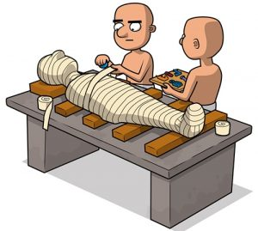
Lesson 8
The Ancient Egyptians.

Open the book that has been attached. It is a PDF file.

Read the section called ‘Mummification Process’, please read both pages.

Task
Recount in chronological order (the correct order), the mummification process.
- Draw a picture for each part of the process.
- Next to each picture or underneath each picture, write what happens during that part of the process.
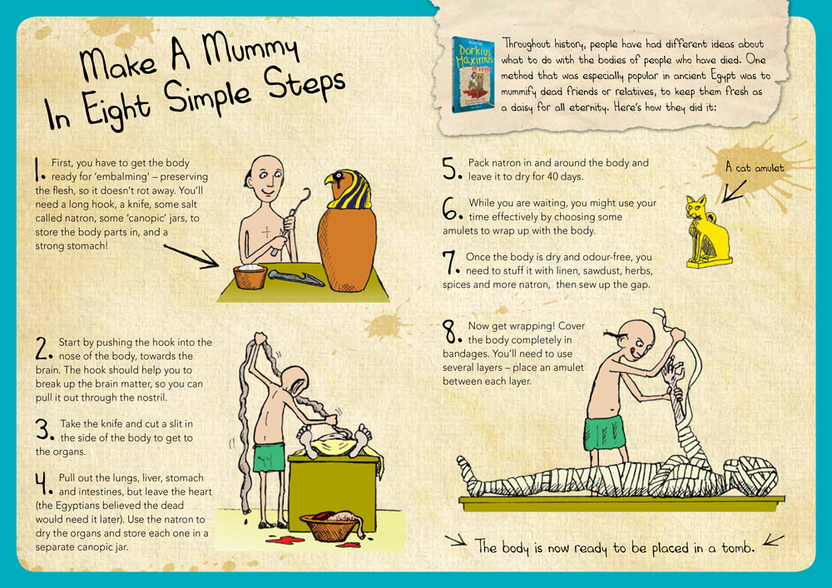
Remember to make sure that your handwriting and colouring in is beautiful and neat.
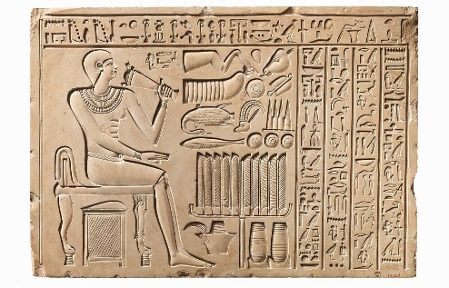
Lesson 9
The Ancient Egyptians.

Open the book that has been attached. It is a PDF file.
Read the section called ‘Hieroglyphs’, please read both pages.
Task
Using the Hieroglyphs below, to help you, write your full name.
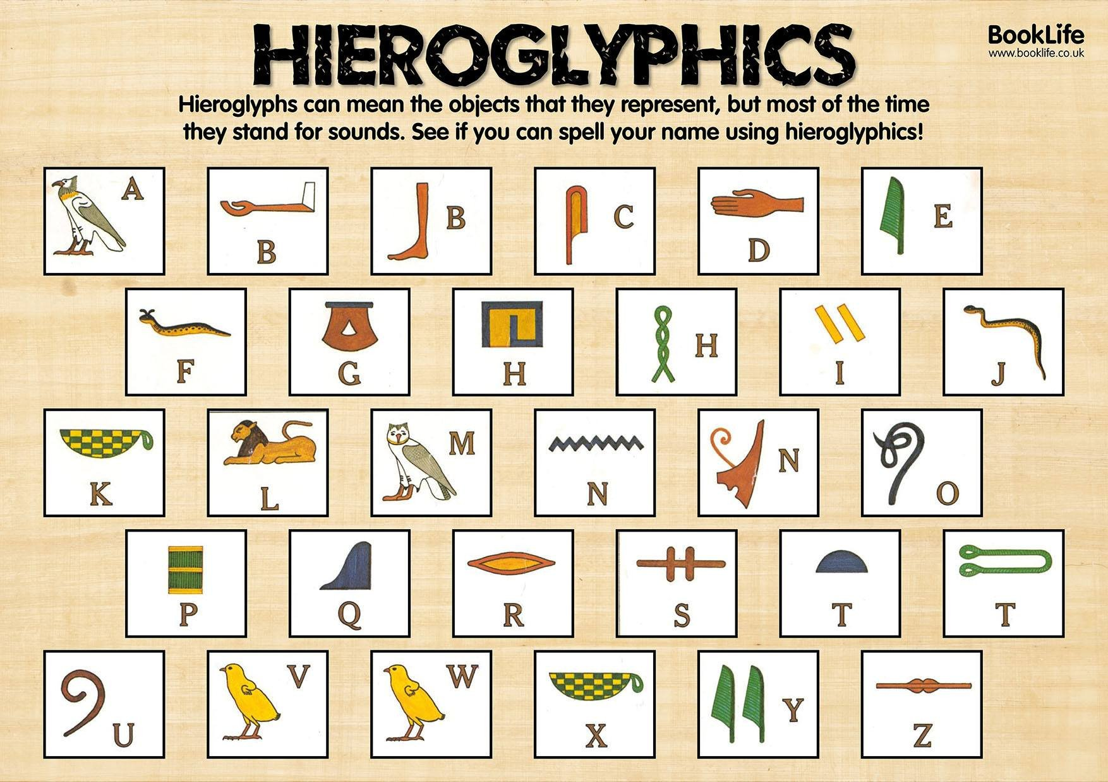
Remember do not write words, use only Hieroglyphs.

Challenge: Can you tell me your favourite subject at school and why you like that subject?

