A Cloudy Lesson
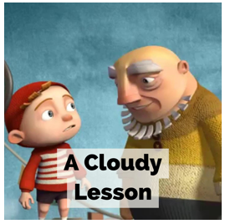

Parental Note: This website has lots of excellent clips which can be used to teach literacy. The website has clips suitable for both primary and secondary age pupils. The clips we have picked are suitable for Key Stage 2 children.

This unit of work is based on a video clip from The Literacy Shed Plus. It can be accessed via https://www.literacyshed.com/cloudylesson.html. There are spaces to write your answers to the questions in the boxes. If possible, use a different coloured font to make your answers stand out.

Important: Do not watch the whole clip to begin with. The first lesson asks you to only watch a short section to begin with.

Day 1 - Questions
Pause the film before the title scene ‘A cloudy lesson’ where the house in the clouds is visible.

What is strange about this house?

Pause the film before the old man blows through the ring.

• Is this an old or young man? How do we know?

• What might their relationship be?

• What do you think he is going to use this tool for?

Pause the film after the old man blows the 1st cloud and gestures the boy to do the same.

• Do you think that this is how clouds are actually made?

• What is the old man saying to the boy?

Finish off this sentence to describe what happened.
With one little puff…

Pause after the boy blows his little cloud.

• His cloud is small – what other words do we know that we can say instead of small?

• How do you think the little boy is feeling?

Pause the film after the boy breaks the ring.

• What has happened?

• What do you think the old man will say to the boy?

Pause the film after the boy has made the ring into a star shape.

• What is the boy’s plan?

Watch the film to the end.

• Is this a happy or sad ending?

• How do we know the characters are happy?

Day 2 – Emotions
Watch the clip. How many of these emotions / attitudes do you see the characters experiencing throughout the short story?

Tick each as you see it (or label with ‘M’ for Man and ’B’ for Boy to show who experienced each emotion).

You may need to watch the clip two or three times.

Horror | Excitement | Jealously | Interest
Frustration | Anger | Annoyance | Pride
Eagerness | Determination | Worry | Shock
Fear | Inspiration | Hatred | Confusion
Clarity | Joy | Disappointment | Love
Exhilaration | Thoughtfulness

Own Ideas

Day 3 – Diary Plan
Imagine that you are the boy from the clip. Plan a diary to detail the events from your perspective. Consider the questions below to help you make a bullet point plan on this page.

My Diary Plan

- Was this your first attempt at blowing clouds?
- Who is the man and why is he training you?
- How were you feeling before your training?
- What was it like trying to blow your first cloud?
- What did the man say to you when you bent the wand?
- Were you expecting what happened next?
- How will you remember this day?

Day 4 – Writing a Diary
Write your diary entry from the point of view of the boy. Use your notes from the last lesson to help you. Also, use the vocabulary in the word bank to help.
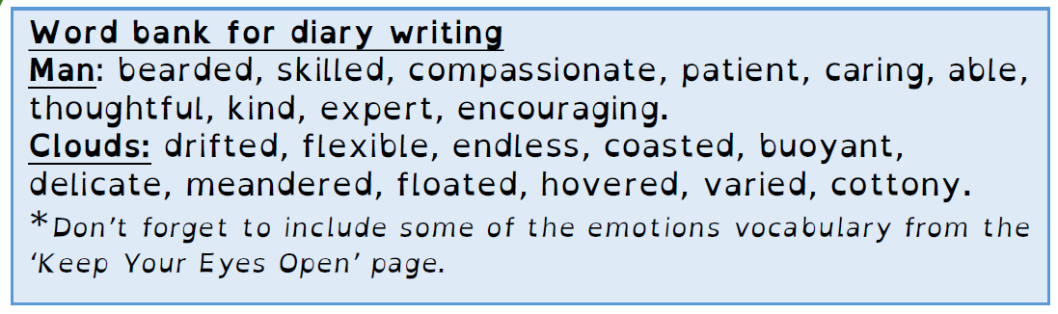

Dear Diary,

Day 5 – Cloud Poetry

Read the example verse carefully and then add more verses of your own 3 line verses following the same patter. The second verse has been started for you.

I drift above the busy world,
And watch the frantic lights of ant-sized cars
Carve the darkness into jagged shapes.

I hover over noisy streets,
And hear

Extra Activities to complete after watching the clip (these do not need to be handed in):
- Create your own written or oral weather report including details of some rather strangely shaped clouds.
- Write the narration and dialogue for the film – remember to use inverted commas correctly.
- Research the science of clouds.
- Design your own ‘wand’ shapes for the clouds you would like to produce and try to sketch the 3D cloud to match each.
- Create a set of instructions to teach a new trainee how to blow clouds.
- Write an information text about the history of cloud blowing.

