Weekly Update
WB: Monday 22nd May 2023
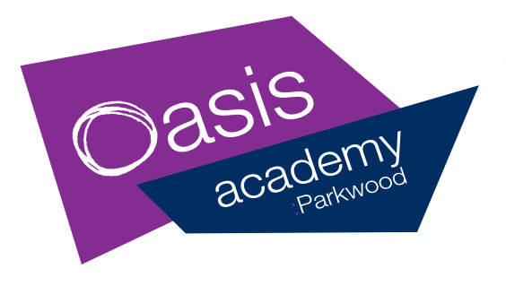

The Week At A Glance |  |  | Messages for Parents
Dinner Menu- Week 3 |  |  | Good Afternoon,  Another busy week in school !  Our Year 2 children are still working hard on their SATs. Year 6 children have already begun to prepare for their move to secondary school and we have transition visits in place and additional transition support for those who may need this.  Parkwood Meadow coming soon !  You may have noticed the gardening work that is taking place outside the main entrance. We have planted a wildflower meadow. PLEASE can you make sure that children do not walk on the grassed area under the office windows and class 1B. This is so that our flowers can bloom !  Our Hub activities will take place on Tuesday and Thursday of the half term. They will be fun filled days with creative craft activities and sports e.g. table tennis, badminton, football, dodgeball and skipping.  The clubs are open to any child in years 1-6. Spaces are limited due to staffing. Demand is always high! Please can we ask again that you only book a place if you are certain your child can attend.  If in extreme circumstances, you do have to cancel – please let Mrs Love know in advance so that the place can be given to a child on the waiting list.  Unfortunately we have experienced times when places are booked and children do not come.  Non-attendance will now be monitored and will affect your child’s ability to book onto future events.  We thank you for your understanding and our desire to provide the activities for as many as possible.  We hope that all families have a lovely weekend.
 | Events In School | After School
Monday | Pupil of the week assembly | 325-400pm  KS1 Fred Club
Tuesday | Safeguarding meeting  Attendance meeting | 325-415pm  Dodgeball club  (last one)
Wednesday | Parkwood Pantry  8.30am-10.00am  Doctor Bike is here today  AM Y6 Visit to Melior – extra transition selected children
Thursday | CLASS PHOTOGRAPHS  Health and Safety meeting  Reading Stars Fixture 9  (in school)  315 New to Parkwood parents meeting- KS1 hall | 3.35-4.30pm  KS2 Drama Club
Friday | Parkwood Pantry  8.30am-10.00am  915 Special Awards Assembly  Close for half term  3.25pm

Free bagels for ALL children
available every morning in class !

SCHOOL FRUIT AND VEGETABLE SCHEME (SFVS)
A free piece of fruit or veg for all FS/KS1 children daily !

Class Attendance
Week Beg 8TH May ‘23
Oak | 96%
Pine | 90%
Willow | 99%
1G | 98%
1B | 95%
2S | 97%
2C | 91%
3B | 90%
4W | 95%
5H | 99%
5W | 96%
6J | 98%
6F | 100%

Parent Course Success !
Well done to all who successfully completed our recent parent course about Helping Your Child With Maths !
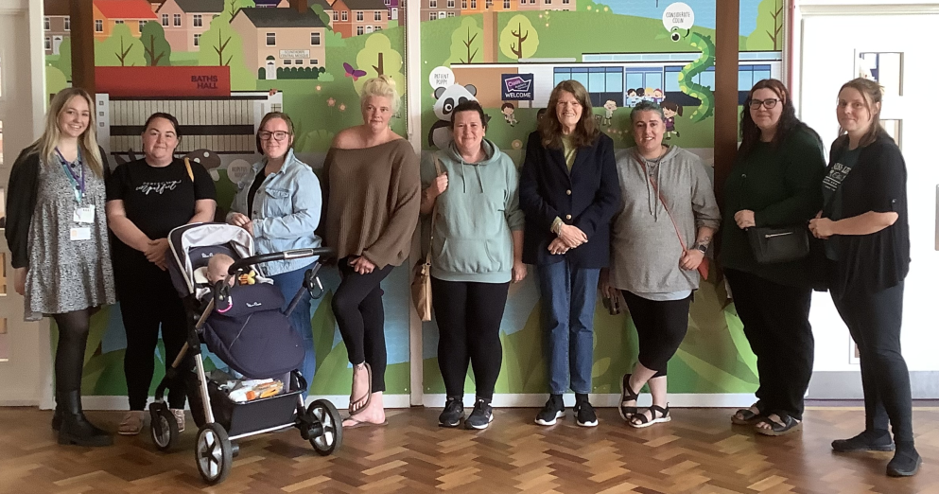
Look out for details of the next course to join.

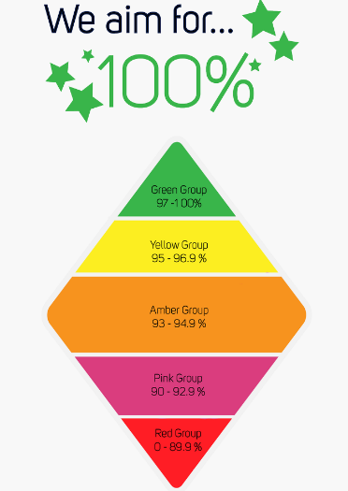

Crafts, sports and activities for all children in Y1-6.
Tuesday 30th May and Thursday 1st June
10am – 2pm.
Pack up needed.

Bookings go live via our MCAS App today (19/5/23) at 4.00pm !

MAY HALF TERM AT THE HUB

TERM | DATES
AUTUMN TERM | Monday 05/09/22 to Friday 16/12/22 | THE Academy is closed on the following dates:  INSET training  Friday 2nd September 2022  Monday 12th September 2022  Friday 14th October 2022  Tuesday 3rd January 2023  Monday 17th April 2023  Friday 23rd June 2023  Monday 24th July 2023  Bank Holidays  Monday 1st May 2023  Monday 8th May 2023
AUTUMN  HALF TERM | Monday 24/10/22 to Friday 28/10/22
SPRING TERM | Wednesday 04/01/23 to Friday 31/03/23
SPRING  HALF TERM | Monday 13/02/23 to Friday 17/02/23
SUMMER TERM | Tuesday 18/04/23 to Friday 21/07/23
SUMMER  HALF TERM | Monday 29/05/23 to Friday 02/06/23
Mon 5th June – Academy re-opens
Wb 12th June – National Phonic Screening checks
Wed 14th June – Reading Stars Football Tournament
Wed 21st June – Official opening of The Hub
Fri 23rd June – INSET day – ACADEMY CLOSED
Wb 26th June – Opening of The Hub to the public

Parkwood At The Baths Hall !

NURSERY PLACES AVAILABLE
Your child can join our successful Nursery as soon as they are 3. Please ask at the office for an admissions form
Summer Visits To The Deep
FS2 – Wed 12th July
Years 1,2, 3 -Tues 18th July
Years 4, 5, 6 – Wed 19th July
The visit will cost £10 per child. Payment is via the MCAS app up to June 30th please.
The term dates are also available on the Academy website:
https://www.oasisacademyparkwood.org/academy-life/term-dates

