Weekly Update
WB: Monday 30th January 2023
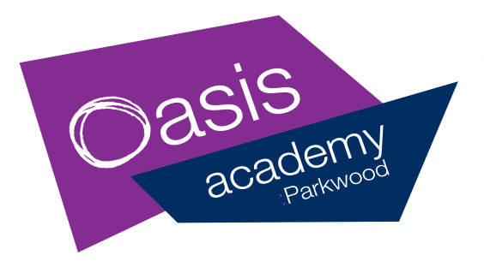

The Week At A Glance |  |  | Messages for Parents
Dinner Menu- Week 1 |  |  | Good Afternoon,  We are delighted that our MET review brought excellent feedback and we are looking forward to receiving the final report. Inspectors were impressed with the children and staff and praised teaching and learning, safeguarding and our community work.  We are aware of the impending NEU teacher strike action but at this time believe that this will not impact at Parkwood and we will remain fully open.  We are looking forward to seeing you at parent evening on Monday 30th. Please make sure that you have booked an appointment with your child’s teacher via the MCAS app.  Bookings are also live on MCAS tonight for the half term activities at the Hub.  We hope that all families have a lovely weekend.
 | Events In School | After School
Monday | Y6 mock SATs this week (Tues -Fri)  Y2 mock SATs contd  Pupil of the Week assembly  PARENT EVENING
Tuesday | Safeguarding meeting  Attendance meeting | 325-415pm  KS2  Dodgeball Club
Wednesday | Parkwood Pantry  8.30am-10.00am  Hub Council Meeting
Thursday | Manage Money Course 4 for parents AM
Friday | Parkwood Pantry  8.30am-10.00am  4W Water Safety Talk  Future Stars visit to EIS Sheffield  Y5 Visit to Young Voices Sheffield  Phase assemblies

Free bagels for ALL children
available every morning in class !

SCHOOL FRUIT AND VEGETABLE SCHEME (SFVS)
A free piece of fruit or veg for all FS/KS1 children daily !

S.O.S: Save Our Sheep!
£698.86
raised so far ! Thank you

Class Attendance
Week Beg: 16th Jan 23
Oak | 99%
Pine | 90%
Willow | 95%
1G | 98%
1B | 98%
2S | 93%
2C | 98%
3B | 96%
4W | 97%
5H | 98%
5W | 95%
6J | 90%
6F | 99%

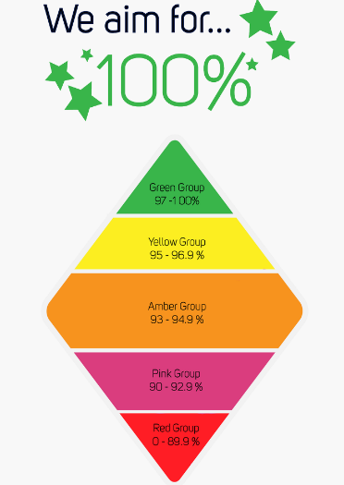

Bookings live on the MCAS App from 4pm Friday 27/1/23
February Half Term At The Hub
The Pantry will be open Wed 9.30-11.00 and Fri 12.00 –1.00
Date | Times | Hub Activity | Age | Places
Tues 14th | 10.00-2.00 | Valentine’s Craft and Mini Disco  (Packed lunch needed) | Y1-6 | 20
Wed 15th | 12.00-2.30 | Cup Cake Making | Y1-6 | 10
Thurs 16th | 10.00-2.00 | Mini Games  (Packed lunch needed) | Y1-6 | 20
Fri 17th | 9.30-12.00 | Movie Morning | Y1-6 | 25

TERM | DATES
AUTUMN TERM | Monday 05/09/22 to Friday 16/12/22 | THE Academy is closed on the following dates:  INSET training  Friday 2nd September 2022  Monday 12th September 2022  Friday 14th October 2022  Tuesday 3rd January 2023  Friday 23rd June 2023  Monday 24th July 2023  Bank Holiday  May Day: Monday 1st May 2023
AUTUMN  HALF TERM | Monday 24/10/22 to Friday 28/10/22
SPRING TERM | Wednesday 04/01/23 to Friday 31/03/23
SPRING  HALF TERM | Monday 13/02/23 to Friday 17/02/23
SUMMER TERM | Tuesday 18/04/23 to Friday 21/07/23
SUMMER  HALF TERM | Monday 29/05/23 to Friday 02/06/23
NURSERY PLACES AVAILABLE
If your child is 3 – they can join our successful Nursery. Please ask at the office for an admissions form
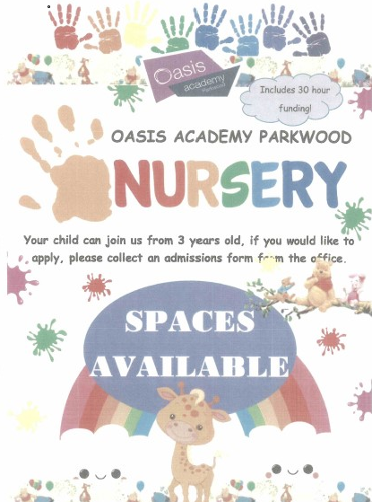
Friday 10th February Special Awards
Thursday 2nd March – World Book Day
Tuesday 28th March – Spring Fair
Wednesday 29th March – Team Awards
Thursday 30th March – Reading, Writing and Maths Awards
Friday 31st March – Special Awards
The term dates are also available on the Academy website:
https://www.oasisacademyparkwood.org/academy-life/term-dates

