Weekly Update
WB: Monday 20Th March 2023
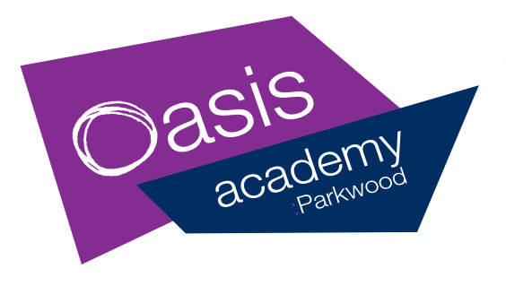

The Week At A Glance |  |  | Messages for Parents
Dinner Menu- Week 2 |  |  | Good Afternoon,  Our Save The Sheep fund has grown again this week through sponsorship of the staff running team who braved the weather and took on the Adventure run at Normanby Park, raising another £181.  Our hearts were warmed also this week with the generosity of three Year 3 children who wanted to give their pocket money and gave us £4.99 for the sheep. Well done Toby, Zachary and Amelia Grace.  Please see page 2 for updates on the run. Our next fundraising for the sheep will be the Easter Fair.  Children and staff have left today for the Robinwood visit. If you child is attending please watch dojo and Facebook for photos of their adventures this weekend!  Next week Year 6 children will sit their Mock Sat tests. These are important assessments so that the children can experience the SATs and so that we can identify and target any learning gaps.  We are pleased that our Parkwood Hub will be offering Easter activities for ALL children in Years 1-6 on April 4th, 5th and 6th. Booking is open from 4pm today. Please see page 3.  We hope that all families have a lovely weekend.
 | Events In School | After School
Monday | Y6 Mock SATS test week  Y1 Mock phonic screening  Pupil of the Week assembly | 325-400pm  KS1 Fred Club
Tuesday | Safeguarding meeting  Attendance meeting  Reading stars Fixture 4  (in school) | 325-415pm  KS2  Dodgeball Club
Wednesday | Parkwood Pantry  8.30am-10.00am | 325-500pm  Y56 Boys  Football league
Thursday | PM Dance Showcase at the Baths Hall – selected children
Friday | Parkwood Pantry  8.30am-10.00am  Phase assemblies

Free bagels for ALL children
available every morning in class !

SCHOOL FRUIT AND VEGETABLE SCHEME (SFVS)
A free piece of fruit or veg for all FS/KS1 children daily !

S.O.S: Save Our Sheep!
£1, 535.79
raised so far ! Thank you

Class Attendance
Week Beg: 6th March ‘23
Oak | 94%
Pine | 96%
Willow | 100%
1G | 97%
1B | 99%
2S | 94%
2C | 99%
3B | 94%
4W | 92%
5H | 94%
5W | 98%
6J | 95%
6F | 97%

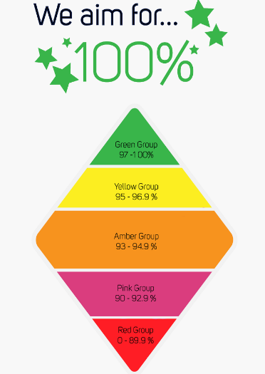

Save Our Sheep
Another massive thank you to our staff running team who completed
a very cold, wet and muddy Adventure Run at Normanby Park last weekend!
Thankyou to all who sponsored them.
Another £181 has been donated to
Our Just Giving page! This is still live and so if you would
like to donate please see this link below
Thank you to everyone !

https://www.justgiving.com/crowdfunding/wf-oasis-parkwood-3?utm_term=bBkgdag8m
TERM | DATES
AUTUMN TERM | Monday 05/09/22 to Friday 16/12/22 | THE Academy is closed on the following dates:  INSET training  Friday 2nd September 2022  Monday 12th September 2022  Friday 14th October 2022  Tuesday 3rd January 2023  Monday 17th April 2023  Friday 23rd June 2023  Monday 24th July 2023  Bank Holidays  Monday 1st May 2023  Monday 8th May 2023
AUTUMN  HALF TERM | Monday 24/10/22 to Friday 28/10/22
SPRING TERM | Wednesday 04/01/23 to Friday 31/03/23
SPRING  HALF TERM | Monday 13/02/23 to Friday 17/02/23
SUMMER TERM | Tuesday 18/04/23 to Friday 21/07/23
SUMMER  HALF TERM | Monday 29/05/23 to Friday 02/06/23
R-Evolution Cycle Hub at Parkwood
If you are interested in the loan of a bike for your child, please see your child’s teacher!

Wanted !
Preloved Soft Toys - please donate to the office . Thank you !

Easter At The Hub Week 1
Easter crafts and activities for all children in Y1-6. All sessions 10am – 2pm. Pack up needed.
Tues 4th April- 20 places
Wed 5th April – 20 places
Thurs 6th April- 20 places
Bookings go live via our MCAS App today (17/3/23) at 4pm !
Summer Visits To The Deep
FS2 – Wed 12th July
Years 1,2, 3 -Tues 18th July
Years 4, 5, 6 – Wed 19th July
The visit will cost £10 per child. Payment can now be made via the MCAS app.
Tuesday 28th March – Spring Fair
Wednesday 29th March – Team Awards
Thursday 30th March – Reading, Writing and Maths Awards
Friday 31st March – Special Awards
Friday 31st March – Academy closes for Easter break at 2.30pm
The term dates are also available on the Academy website:
https://www.oasisacademyparkwood.org/academy-life/term-dates

